**To install the program in Windows, run the latest .msi file. Then, you should be able to launch the tool like any other program. In MacOS, you’ll need to open the mac compiled folder in bash and run ‘ ./”APS Career Data Processing Tool” ’.**

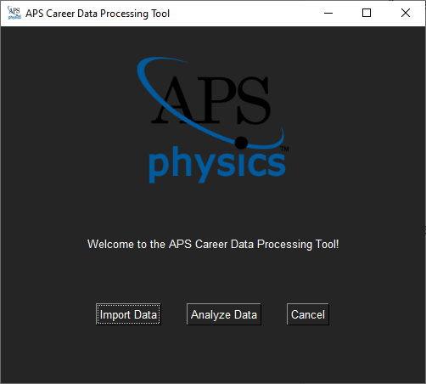

**Once you have installed and ran the tool, this should be the first screen you see, aside from the popup which installs dependencies. Here, “Import Data” will open a window to import job data from csv files into our database, and “Analyze Data” contains the tools we use to get our results.**

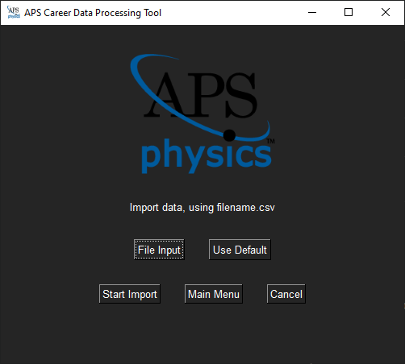

**When you open the import window, you should see this menu. “File Import” allows you to select a csv file that contains the data you wish to analyze. This needs to be formatted with the columns in the same order as the example file (located in the install directory). The “Use Default” button will populate the database with data included with the tool (in v1.1, this data ends in June 2021). “Start Import” will actually populate the database, once you have selected the file.**

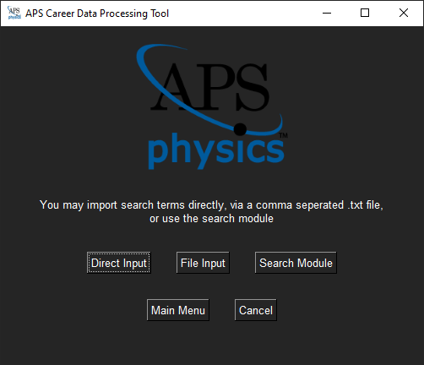

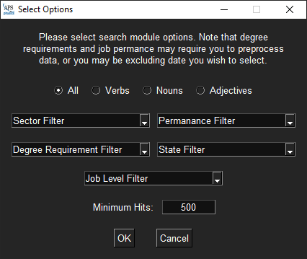**The analyze menu allows you to get results. Clicking “Direct Input” allows you to directly enter keywords to be counted by conditions you select. Terms must be comma separated and may contain “+”, the AND operator, and “|”, the OR operator. You may also directly import keywords from a text file using “File Input,” with the same format constraints as “Direct Input”. The “Search Module” option allows you to automatically find common keywords in the job descriptions.**

**In the search module, you can select the parameters of your search for common keywords. First, you can select the word type, which will filter out all words except your word type. Likewise, you can filter your results by sector, permeance, degree, location, and job level. Finally, you can select the minimum occurrences that a keyword must have to appear in your results. Unlike when you analyze with these keywords, this will count every occurrence of a word, not just one occurrence per job posting.**

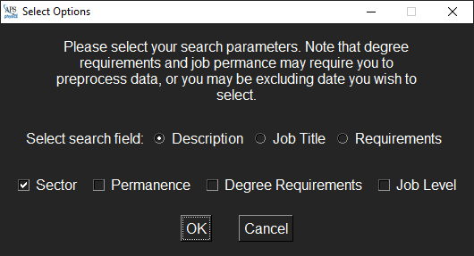**Once you have selected keywords from “File Input,” “Direct Input,” or “Search Module,” you can select analysis options in this menu. The search field radio buttons allow you to select which fields analyze. The checkboxes allow you to select which column you want, searching based on sector, permanence, etc. After you have hit OK, you can preview your results and export to csv by using the relevant dialogs. The export location defaults to your documents folder, you may change it to any valid path.**